Reading a Line Equation and Plotting It
In the equation - mx + b , m = the slop and b = the point on the y axis
If the slope is a positive number, such as 2, read it as 2/1. Two up the y axis, 1 one over to the right on the x axis.
If the slope is a negative number, such as -2, read it as -2/1. Two down the y axis, one over to the right on the x axis. You can read it as two up the y axis and one over to the LEFT on the x axis. The line that is created will be the same.
Graph the equation y = ( ³/₅ ) x – 2 from the slope and y-intercept.
From the equation, I know that the slope is m = ³/₅, and that the line crosses the y-axis at
y = –2. Copyright © Elizabeth Stapel 2000-2011 All Rights Reserved
 |  | 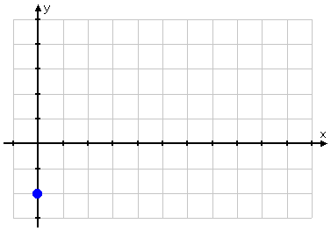
From this point, I go up three and over five: |  | 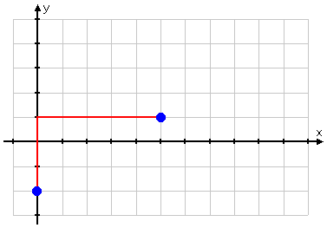

When graphing a negative slope, which means the number in front of ‘x’ is negative, the line will run from top left to down right.
- Graph the equation y = -2 x + 4 from the slope and y-intercept.
ll Rights Reserved
I'll start by plotting this first point:
Now the second.

One common line to graph is the parabola—a U shape (upper Geometry)
You probably won’t be asked to graph it, but you might be asked to identify if the equation for a vertical one and a horizontal one.
Remember the patterns:
If ‘a’ is positive, U goes up or U goes to the right. If ‘a’ is negative, U goes down or U goes to the left.
Vertical means the U up or down
Horizontal means the U is side to side, or lying flat

1. Find the equation of this parabola
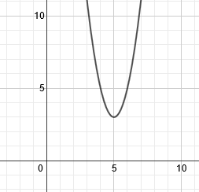
This is a vertical parabola, so we are using the pattern
Our vertex is (5, 3), so we will substitute those numbers in for h and k:
Now we must choose a point to substitute in. You can choose any point on the parabola except the vertex. Let's use (4, 5). We'll substitute 4 in for x and 5 for y.
Now we'll solve for a:
5 = a(1) + 3
2 = a

To finish, we rewrite the pattern with h, k, and a:

2. Find the equation of the parabola:
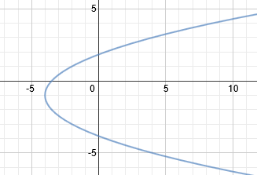
This is a vertical parabola, so we are using the pattern
Our vertex is (-4, -1), so we will substitute those numbers in for h and k:
Now we must choose a point to substitute in. You can choose any point on the parabola except the vertex. Let's use (4, 3). We'll substitute 4 in for x and 3 for y.
Now we'll solve for a:
4 = a(16) - 4
8 = 16a
1/2 = a
To finish, we rewrite the pattern with h, k, and a:

Practice: Find the equation of these parabolas.
